CAPSTONE PROJECT MID -TERM SUBMISSION

**"Maximising Customer Satisfaction by Reducing Order Delay: A Tailor Shop's Labor Force Dilemma”**

NAME: ARSHI KHAN

ROLL NO: 21F3002806

**"Maximising Customer Satisfaction by Reducing Order Delay: A Tailor Shop's Labor Force Dilemma"**

**Executive Summary**

# Introduction:

This executive summary provides an overview of the project aimed at maximising customer satisfaction by reducing order delays in a tailor shop. The project addresses the labour force dilemma faced by the shop, which has resulted in inconsistent workforce availability and delayed orders. The tailor shop, being a key player in the local market, has built a strong reputation for its high-quality craftsmanship and personalised tailoring services. However, the recent labour force challenges have posed significant obstacles to maintaining its exceptional customer service standards and meeting customer expectations. Recognising the importance of customer satisfaction in sustaining and growing their business, the tailor shop is committed to resolving the labour force dilemma and optimising its operations to ensure timely order fulfilment and exceed customer expectations.

# Background of the Company:

The tailor shop was founded in 1995 by Mr. Rajesh Kumar in a small town in Uttarakhand, India, now it is being run by Mohd. Asad who is the current owner of the shop. They offer a variety of tailored clothing items for both men and women, alteration and repair services, and have a team of 10 skilled employees. The shop has a flat organisational structure, a good reputation for high-quality work, and serves customers from the local community and neighbouring towns. The mission of the shop is to provide personalised service and tailored clothing items that fit well and make customers feel good. The net worth of the tailor shop would be around 1,080,000 INR.

Problem Statement:

The tailor shop is currently facing challenges due to an inconsistent labour force, leading to delays in order fulfilment. This has resulted in customer dissatisfaction, missed deadlines, and potential loss of business opportunities. The shop needs to address this issue to ensure timely delivery, improve customer satisfaction, and maintain a competitive edge in the market.

# Objective:

The primary objective of this project is to optimise the labour force management in the tailor shop, aiming to minimise order delays and maximise customer satisfaction. By addressing the labour force dilemma and implementing efficient workforce planning strategies, the shop aims to improve order fulfilment timelines and enhance the overall customer experience.

# Proposed Solution:

To address the labour force dilemma, the project will focus on the following key areas:

1. Workforce Planning: Implementing a systematic approach to workforce planning to ensure adequate staffing levels based on order volume and demand fluctuations.
2. Training and Development: Providing training and development opportunities to enhance employee skills and improve productivity.
3. Absence Management: Implementing strategies to manage employee absences and minimise the impact on order fulfilment.
4. Process Optimisation: Identifying and streamlining operational processes to increase efficiency and reduce bottlenecks.

# Expected Outcomes:

By successfully implementing the proposed solution, the tailor shop expects to achieve the following outcomes:

1. Reduced Order Delays: Timely fulfilment of customer orders, resulting in a significant reduction in order delays.
2. Improved Customer Satisfaction: Enhanced customer experience through prompt delivery, leading to increased customer satisfaction and loyalty.
3. Increased Operational Efficiency: Streamlined processes and optimised labour force management, resulting in improved productivity and cost-effectiveness.
4. Competitive Advantage: Differentiation in the market by providing superior customer service and meeting or exceeding customer expectations.

# Conclusion:

The project "Maximising Customer Satisfaction by Reducing Order Delay: A Tailor Shop's Labor Force Dilemma" addresses the crucial issue of inconsistent labour force and order delays in the tailor shop. By implementing efficient workforce planning strategies, training and development programs, absence management systems, and process optimisations, the tailor shop aims to improve order fulfilment timelines and customer satisfaction. Successful execution of this project will enable the tailor shop to strengthen its position in the market, enhance its reputation for reliability, and maximise customer satisfaction.

**SOURCE OF DATA:**

All the data is provided by Mr. Asad who is the owner of City Light Tailor. Please find below letter given from the business to validate the authenticity of the data.

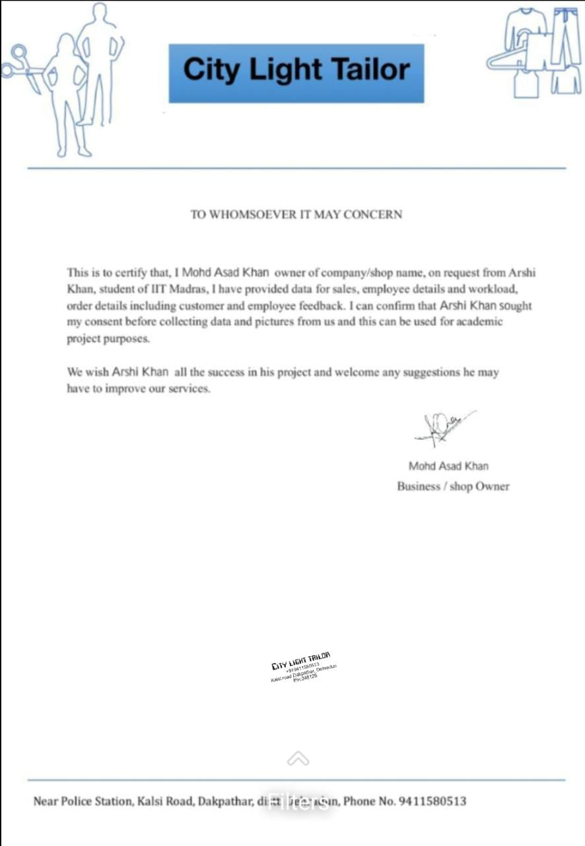

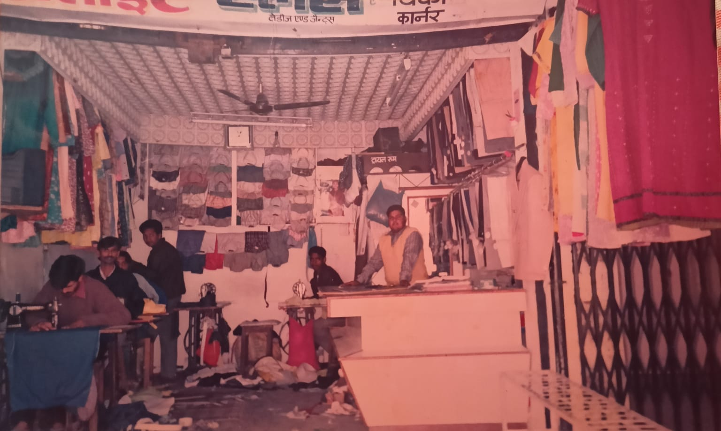

**METADATA AND DESCRIPTIVE STATISTICS**

Collected order data, promised delivery date and actual delivery, workload of employees and customer survey data and employee survey data for 4 months i.e., January 2023 to April 2023.

Here is the introductory video given by the daughter of the owner as she will be running the business in the near future [owner's talk](https://drive.google.com/file/d/1MwaIzElYrHLEVs3ittz4SgJwNVIJSm2t/view?usp=share_link).

The **"Employee Attendance and Details"** sheet provides a comprehensive overview of employee attendance patterns, including the number of days present, absenteeism rates, and other relevant details. This data helps in understanding and analysing employee attendance trends, identifying patterns of absenteeism, and formulating strategies to improve attendance and workforce management.

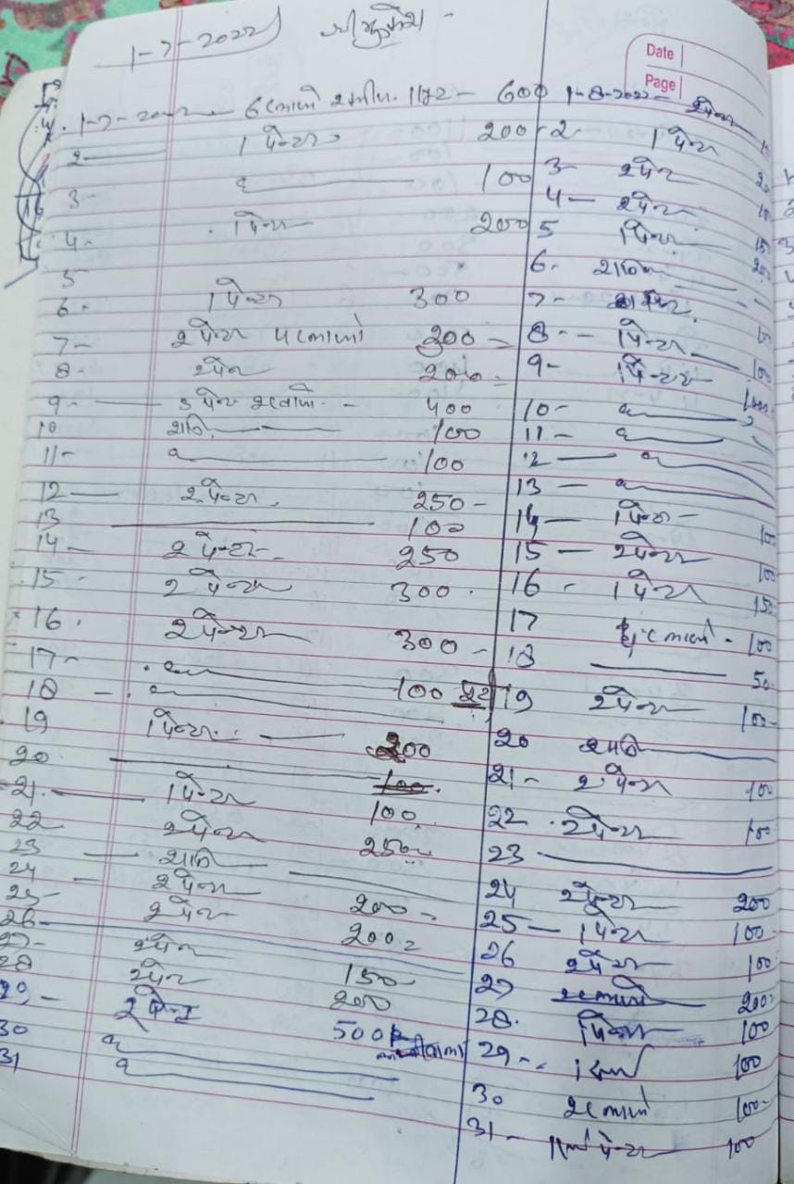

Original data contains

* Name of the employee
* Workload
* Actual work done
* Advance taken

**Order booking:**

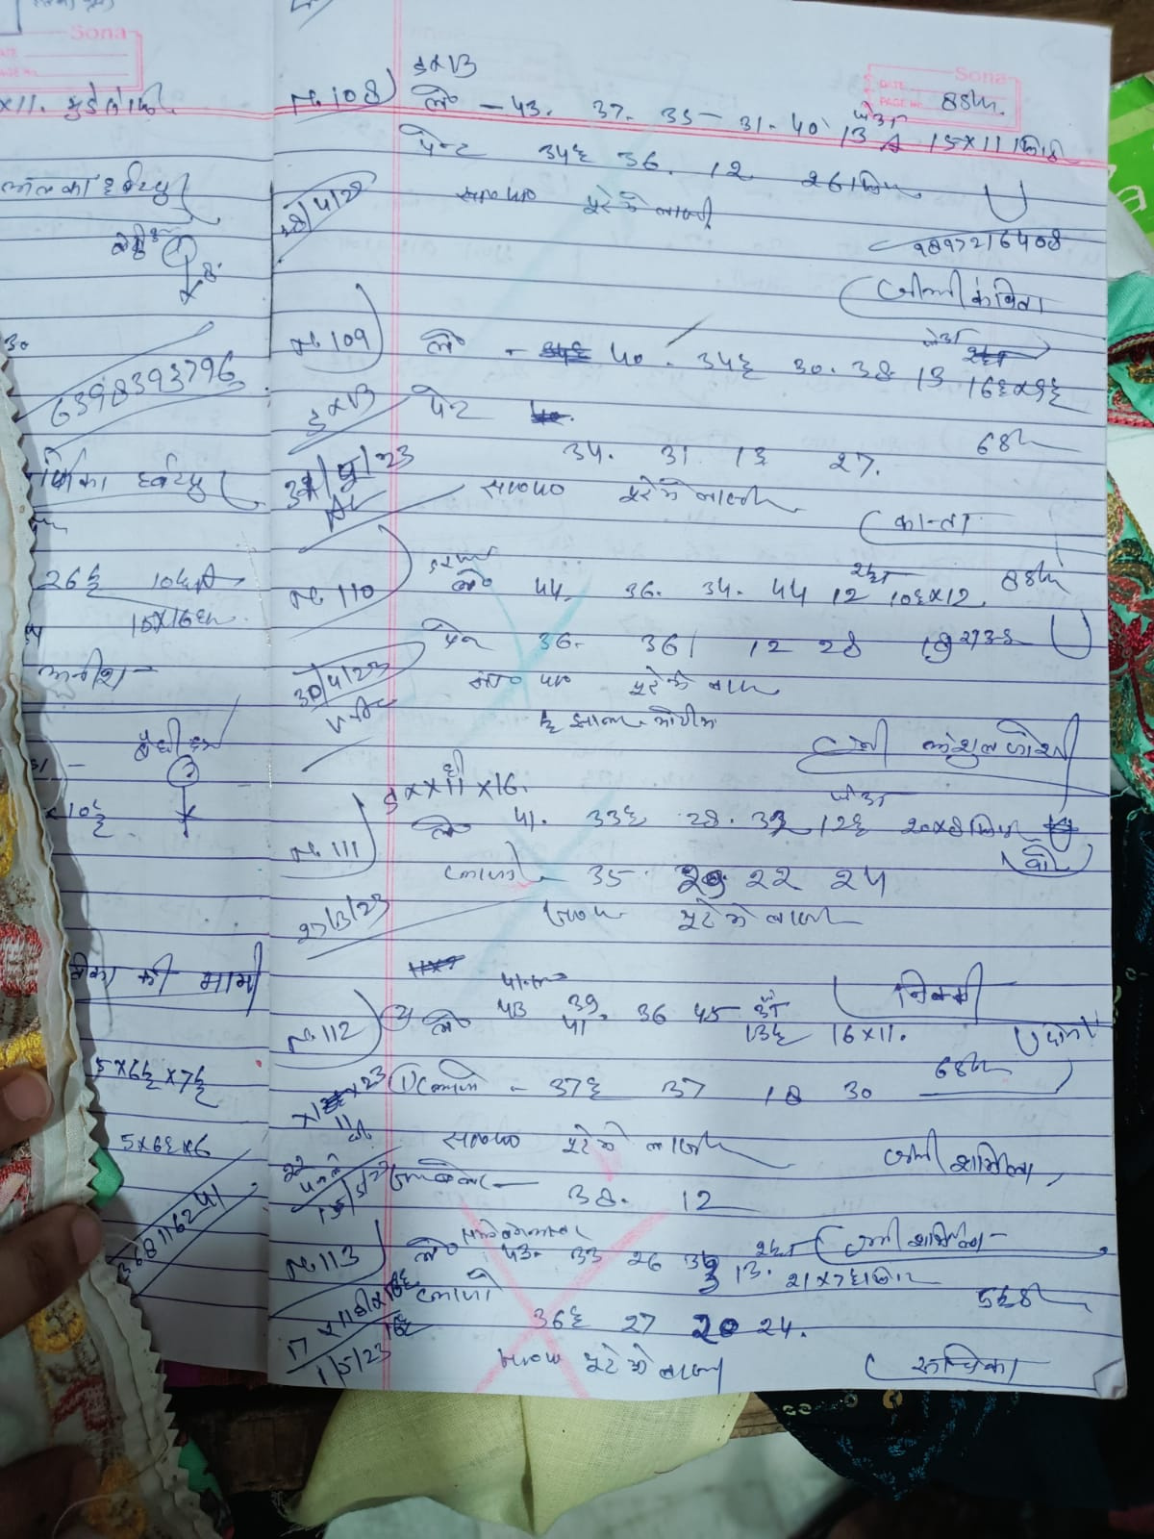

Original data contains

* Date of booking order
* Order details
* Delivery date expected

**Bill/Sales data:**

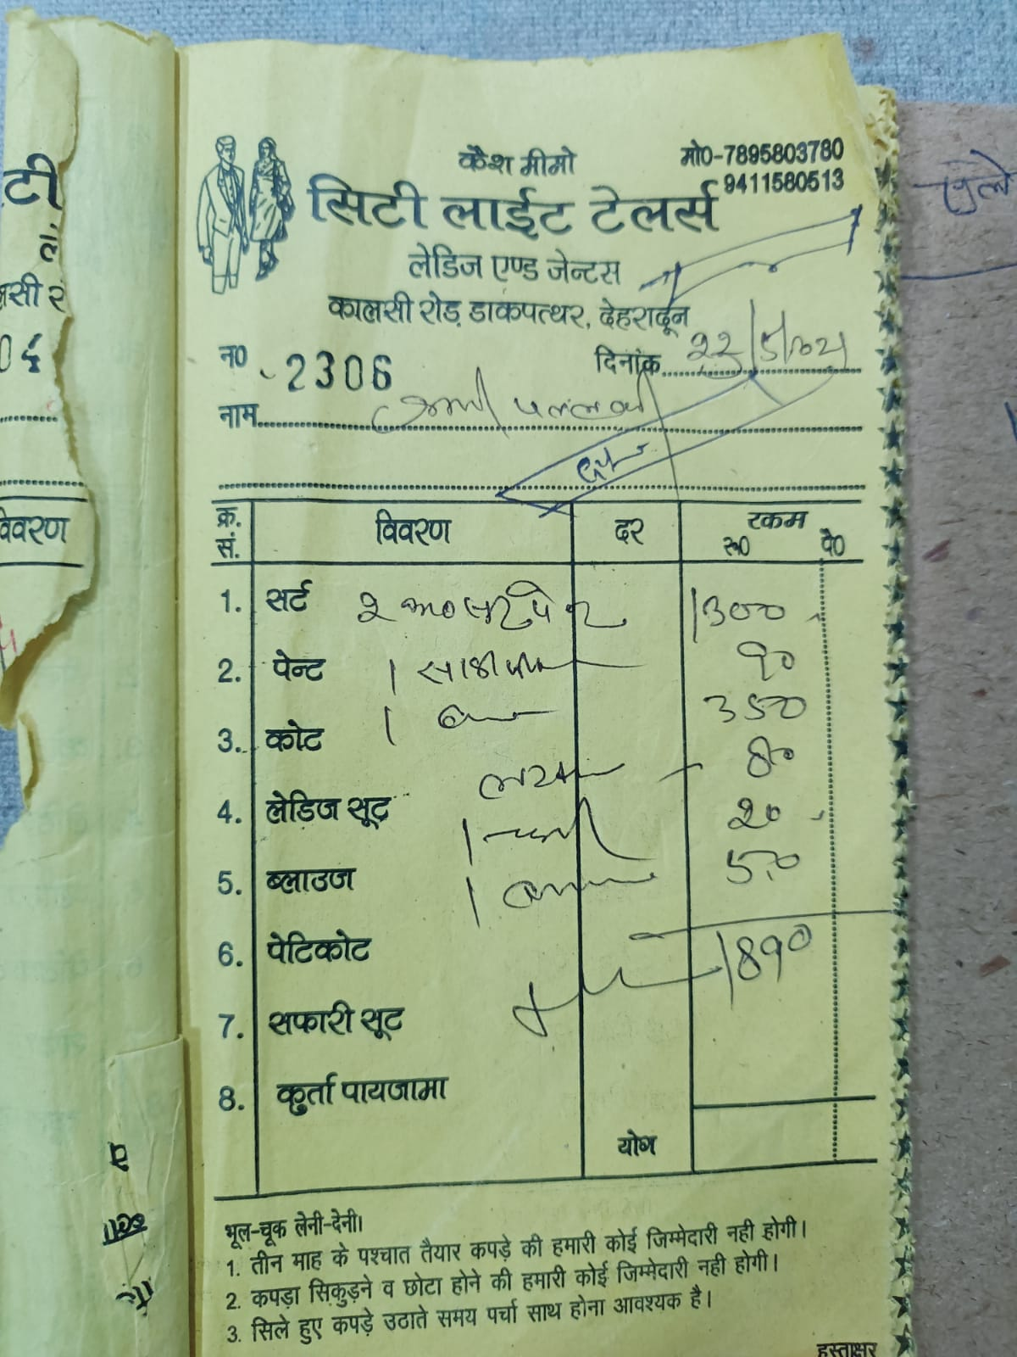

Original data contains

* Actual delivery date
* Order details
* Cost

1. In the given link of the video, I have shown some data collection and cleaning process as my project is on a small tailor shop which keeps manual data and with the help of the owner’s daughter I was able to transfer the data into electronic form.

[Data collection](https://drive.google.com/file/d/1IEMvqk8rfsZfia7sCx6ka63Mw3T9EX-W/view?usp=share_link)

1. The collected data in its raw form may contain inconsistencies, errors, and missing values. Therefore, it is important to acknowledge that the data collected requires cleaning and preprocessing before it can be used for analysis and decision-making. Here is [Raw data](https://drive.google.com/file/d/1dOdJS92jzah8IfxuqR_-NcshFyC7W7tD/view?usp=share_link) link.

**Cleaned data:**

1. Employee Attendance and Details: This sheet provides information on employee attendance, including dates of attendance, absences, leaves, and other relevant details. It assists in monitoring employee attendance patterns, identifying absenteeism trends, and managing workforce scheduling and productivity.

Contains fields:

* Date
* Employee No.
* Employee Details
* Name of the employees
* Designation
* Place of residence
  + Total number of employees: 12
  + Average attendance rate: 75.89
  + Absenteeism rate: 24.104
  + Maximum and minimum attendance: Employee No. 10 and Employee No. 6
  + Standard deviation: 21.1975142

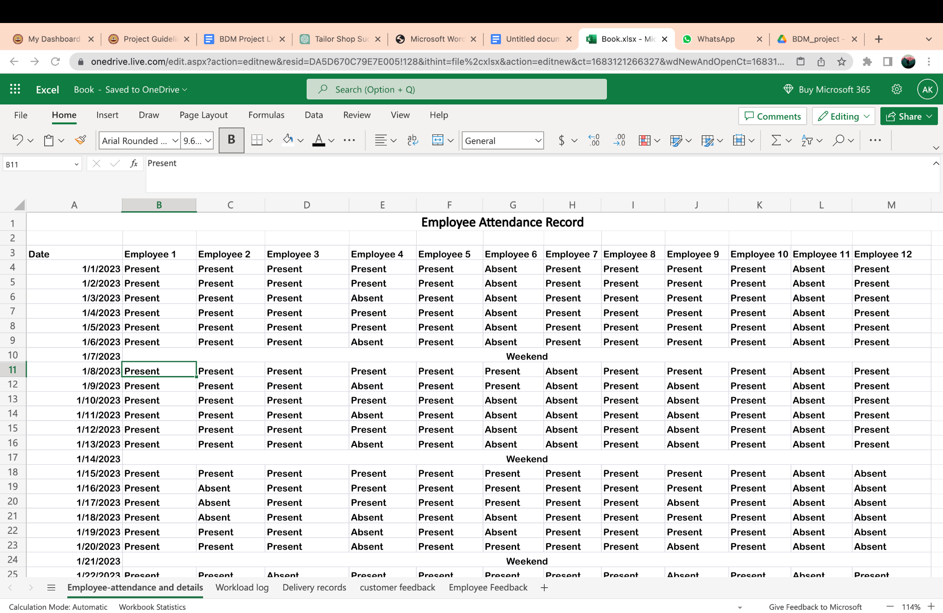

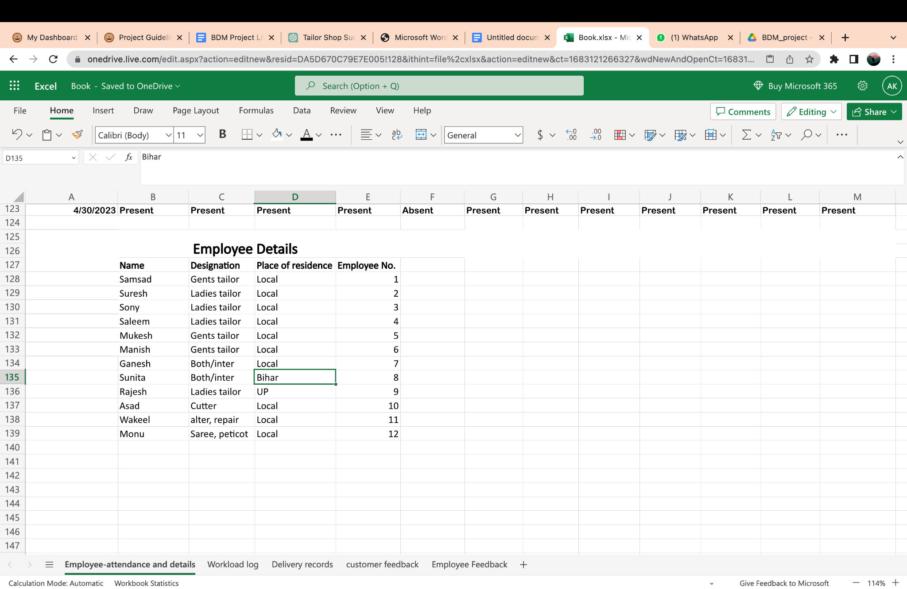

1. Workload Log: This sheet tracks the workload assigned to employees, highlighting the tasks, timeframes, and workload distribution. It allows for assessing workload balance, identifying potential workload bottlenecks, and optimising resource allocation to enhance efficiency.

Contains fields:

* Date
* Employee Name
  + Workload of Sunita is the least with 5.05.
  + Workload of Asad is the most with 9.68
  + Asad has the highest variation in the tasks assigned, being 3.98.
  + Most consistent workload is of Sunita with 1.43 variation.

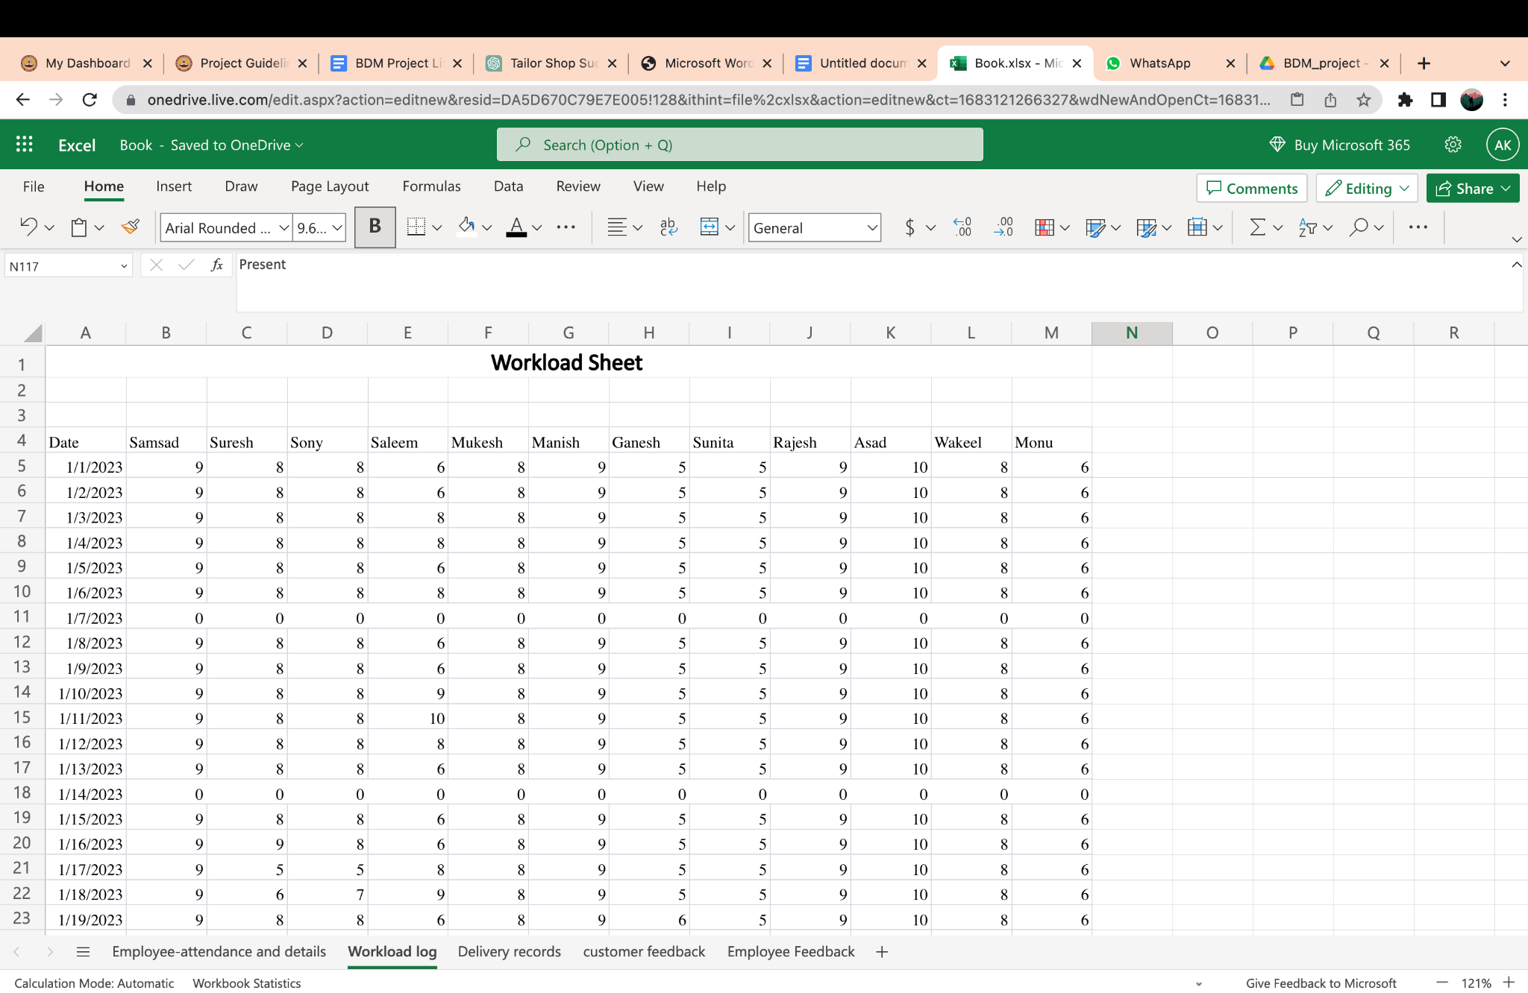

1. Delivery Records: This sheet records the details of customer orders, including order dates, shipping dates, expected delivery dates, actual delivery dates, and order statuses. It helps evaluate order fulfilment timelines, identify delays, and improve the efficiency of the delivery process.

Contains fields:

* Order_number
* Date
* Expected date
* Actual date
* Delayed
* Cost
  + Delivery time: 4 days after expected date
  + On-time delivery percentage: 12.9%
  + Early delivery percentage: 13.1%
  + Delayed orders: 74%

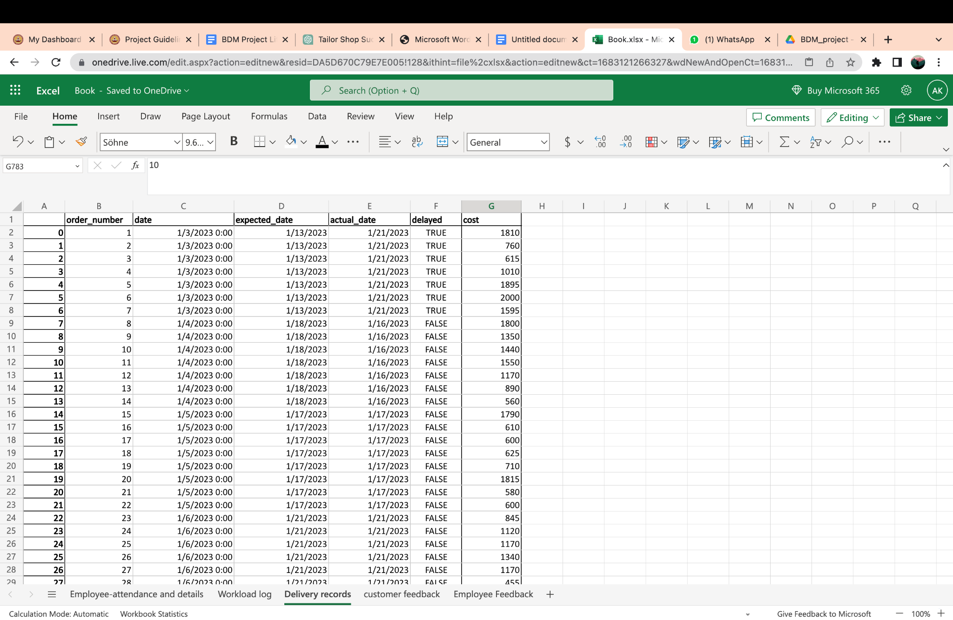

1. Customer Feedback Data: This sheet contains feedback provided by customers, including their satisfaction ratings on product quality, delivery time, customer service, and pricing. It enables an understanding of customer sentiments and areas for improvement in the business.

Contains fields:

* Date
* Questions
  + Overall satisfaction rate: 3.37/5
  + Distribution of satisfaction ratings: They are most satisfied with the quality of the order with an average rating of 4.25/5.

They are least satisfied with the delivery time with an average rating of 2(as expected and stated in my problem statement).

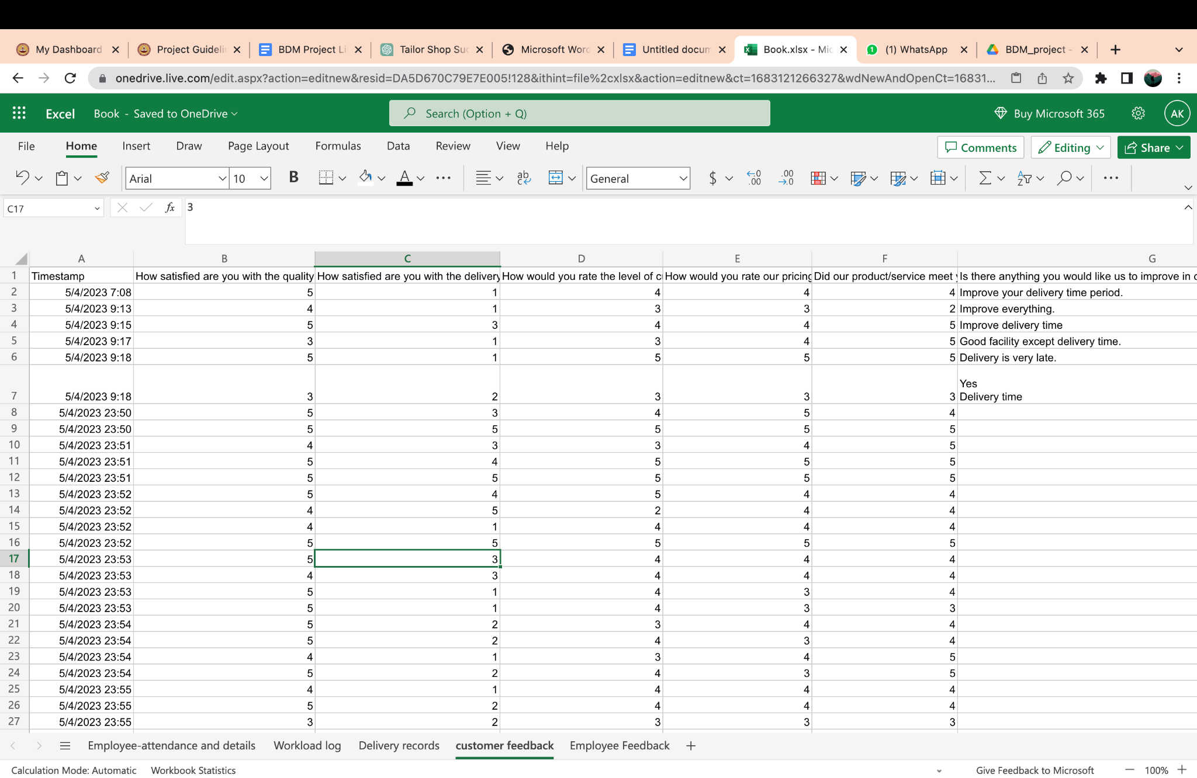

1. Employee Feedback Data: This sheet captures feedback from employees, covering aspects such as workload balance, management support, communication, and recognition and rewards. It helps gauge employee satisfaction levels and identify areas that require attention to enhance employee engagement and productivity.

Contains fields:

* Date
* Questions
  + Employee satisfaction rates: 2.94/5 (They are not ecstatic to work but they are not heavily dissatisfied either.)
  + Identify areas of improvement: workload balance is rated 2.76 and satisfaction with assigned work is 2.84 which should improve.

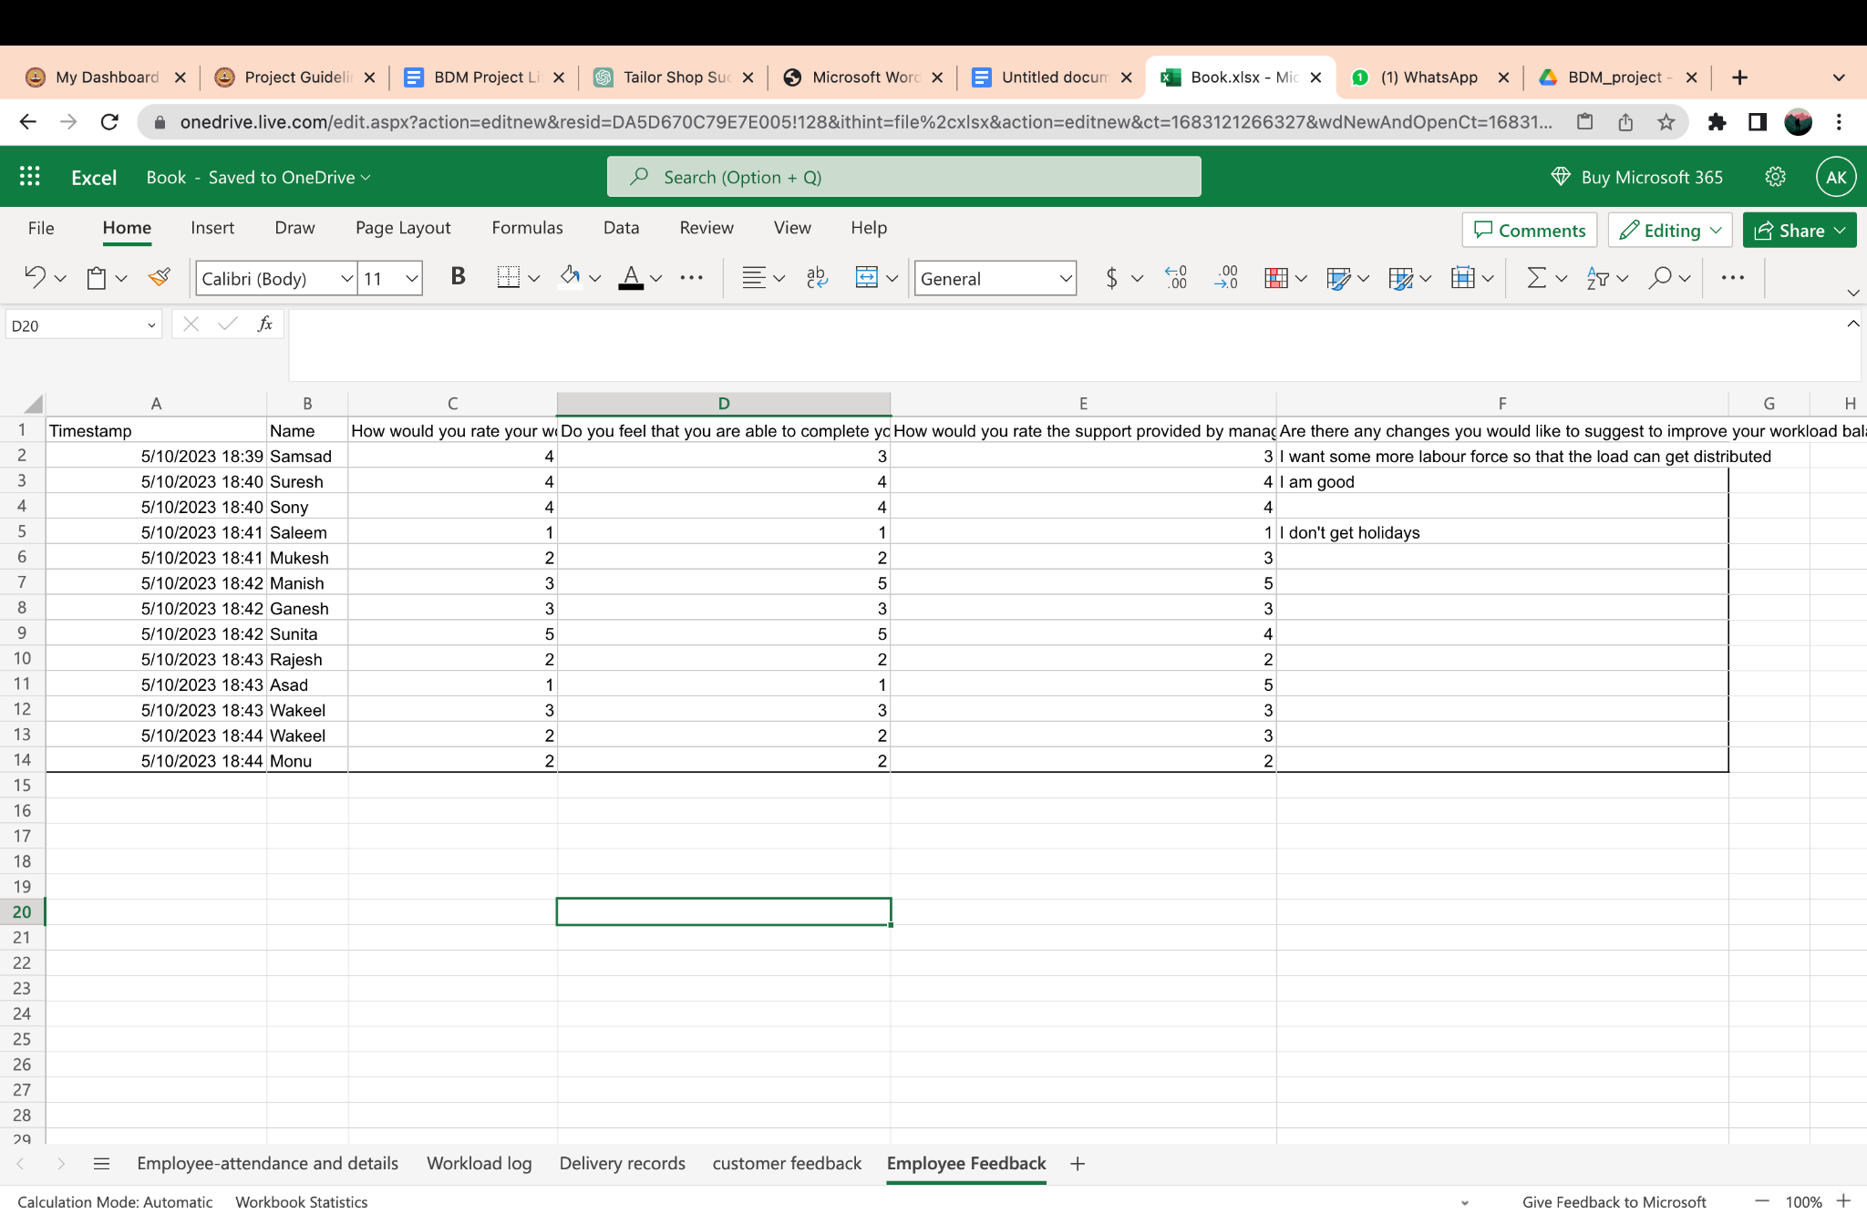

Please use the below link to see cleaned data.

[Clean Data](https://docs.google.com/spreadsheets/d/15JRfmZx8aRPYsKeBvi84shut6RgaPcYr/edit?usp=share_link&ouid=111328334584857870397&rtpof=true&sd=true)

ANALYSIS PROCESS:   
The analysis process involves extracting meaningful insights and patterns from the collected data sheets to inform decision-making and drive improvements. It consists of several key steps:

1. Data Cleaning and Preparation: Before analysis can begin, the data from each sheet needs to be carefully cleaned and prepared. This involves checking for missing values, correcting any errors or inconsistencies, and ensuring uniformity in data formats. By addressing these issues, the data becomes more reliable and ready for analysis.
2. Data Integration: The different data sheets, including customer feedback, employee feedback, attendance, workload log, and delivery records, may need to be integrated to create a comprehensive dataset for analysis. This allows for a holistic view of the business operations and their interconnectedness.
3. Descriptive Statistics: Descriptive statistics provide a summary of the data, such as measures of central tendency (mean, median, mode) and measures of dispersion (standard deviation, range). These statistics help in understanding the distribution, variability, and overall characteristics of the data.
4. Data Visualisation: Data visualisation techniques, such as charts, graphs, and plots, are used to present the data in a visual format. This aids in identifying trends, patterns, and relationships within the data more easily. Visual representations can include bar charts, line graphs, scatter plots, and pie charts, among others.
5. Statistical Analysis: Statistical analysis techniques can be applied to explore relationships, correlations, and trends within the data. This may involve conducting regression analysis, hypothesis testing, correlation analysis, or other relevant statistical methods to gain deeper insights and validate findings.
6. Key Performance Indicators (KPIs): Key performance indicators are specific metrics used to measure the performance and effectiveness of various aspects of the business. By defining and tracking KPIs, such as customer satisfaction rates, employee satisfaction rates, on-time delivery percentages, or absenteeism rates, the analysis can focus on assessing performance against set targets and identifying areas for improvement.
7. Interpretation and Insights: The analysis process culminates in interpreting the findings and extracting actionable insights. This involves drawing conclusions, identifying trends, patterns, and outliers, and linking the data analysis results to the identified problem areas or objectives. These insights provide valuable guidance for making informed decisions, implementing necessary changes, and driving continuous improvement.

By following a systematic and rigorous analysis process, the data can be transformed into meaningful information that informs business strategies, enhances operational efficiency, and ultimately contributes to the success and growth of the organisation.

RESULTS AND FINDINGS (Mid-Term Study results)

**Employee Attendance and Details:** The analysis of the "Attendance" data reveals an outlying value of 28.43, indicating that there are employees who consistently have significantly lower attendance rates compared to others. This finding highlights the importance of addressing attendance issues within the workforce.

While the majority of employees maintain attendance rates above 75%, it is essential to emphasise the significance of regular attendance for maximising the delivery rate and minimising delays. Employees with lower attendance may contribute to productivity gaps and hinder the smooth flow of operations.

To enhance overall performance and ensure timely order fulfilment, it is crucial to address the attendance challenges faced by these employees. By fostering a culture of punctuality and emphasising the value of consistent attendance, the business can strive towards improving operational efficiency and meeting customer expectations.

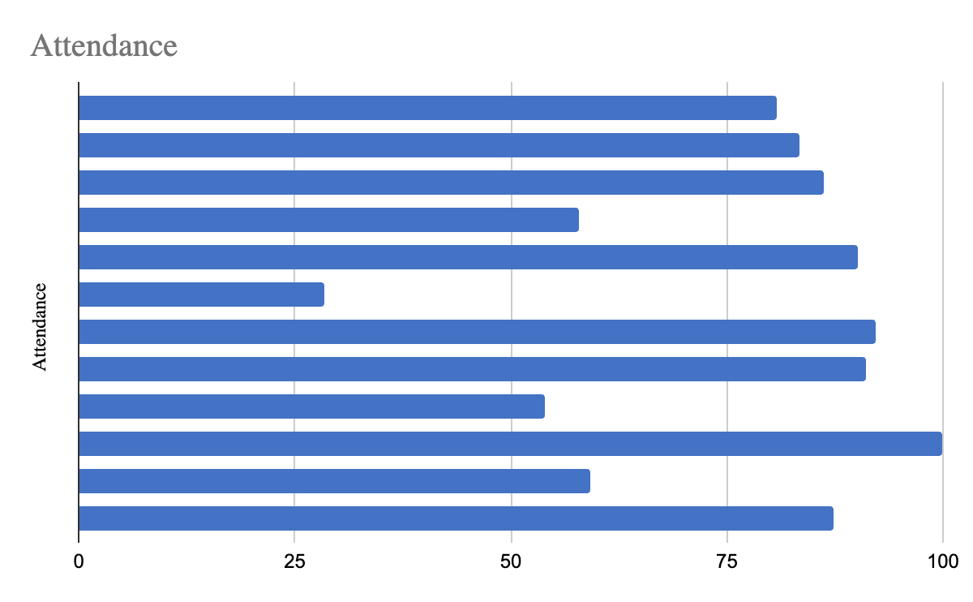

**Workload Log:** The analysis of the "Workload" log reveals interesting findings about the distribution and variation of tasks assigned to different employees. Among the employees, Sunita has the lowest workload with a value of 5.05, indicating that she is assigned fewer tasks compared to others. On the other hand, Asad has the highest workload with a value of 9.68, indicating that he is assigned a higher number of tasks.

Additionally, the analysis shows that Asad has the highest variation in the tasks assigned, with a value of 3.98. This suggests that his workload fluctuates significantly, indicating potential challenges in workload management and resource allocation. On the contrary, Sunita has the most consistent workload with a variation of 1.43, indicating a relatively stable assignment of tasks.

These findings shed light on the distribution and variability of workload within the organisation. The high workload of Asad and his significant variation in tasks assigned may indicate a need for workload balancing strategies and better resource allocation. Conversely, the consistent workload of Sunita showcases her potential for taking on additional tasks or redistributing workload to ensure better efficiency and productivity.

By addressing workload disparities and implementing strategies for workload optimisation, the organisation can aim to achieve a more balanced and efficient distribution of tasks among employees, leading to improved productivity, reduced delays, and enhanced overall performance.

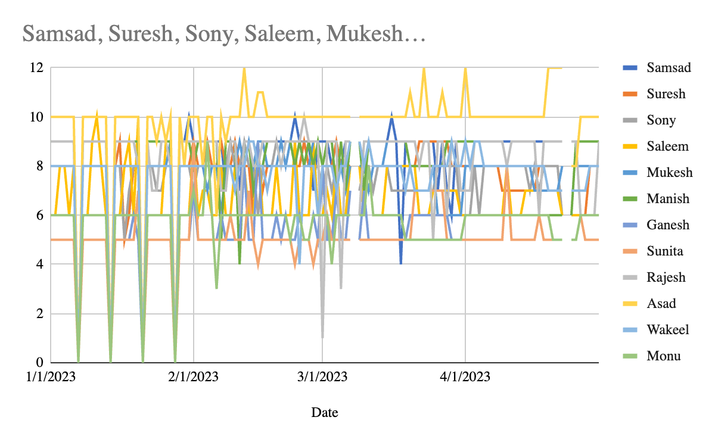

**Delivery Records:**The analysis of the "Delivery Records" provides valuable insights into the timeliness and performance of order deliveries. The data reveals notable patterns and findings that can inform decision-making and process improvement.

One key finding is that the majority of orders were delayed, with delivery dates extending beyond the expected delivery dates. This indicates a potential issue in meeting customer expectations and timely order fulfilment. It is evident that there is room for improvement in the delivery process to minimise delays and enhance customer satisfaction.

Another important observation is that there is a wide range of delivery time variations across different orders. Some orders were delivered earlier than the expected delivery date, while others experienced significant delays. This indicates a lack of consistency and predictability in the delivery process. Addressing this variation and improving delivery time management can contribute to more reliable and efficient order fulfilment.

Graphical representation of the delivery records can provide a clear visualisation of the delivery status for each order. Bar charts or line graphs can be used to depict the actual delivery dates in comparison to the expected delivery dates, highlighting the delays and early deliveries. This visual representation can help identify trends and patterns, facilitating decision-making and targeted improvements.

By analysing the delivery records and understanding the factors contributing to delays or early deliveries, the organisation can develop strategies to streamline the delivery process, optimise logistics, and enhance overall operational efficiency. Timely and reliable order deliveries are crucial for customer satisfaction, repeat business, and maintaining a competitive edge in the market.

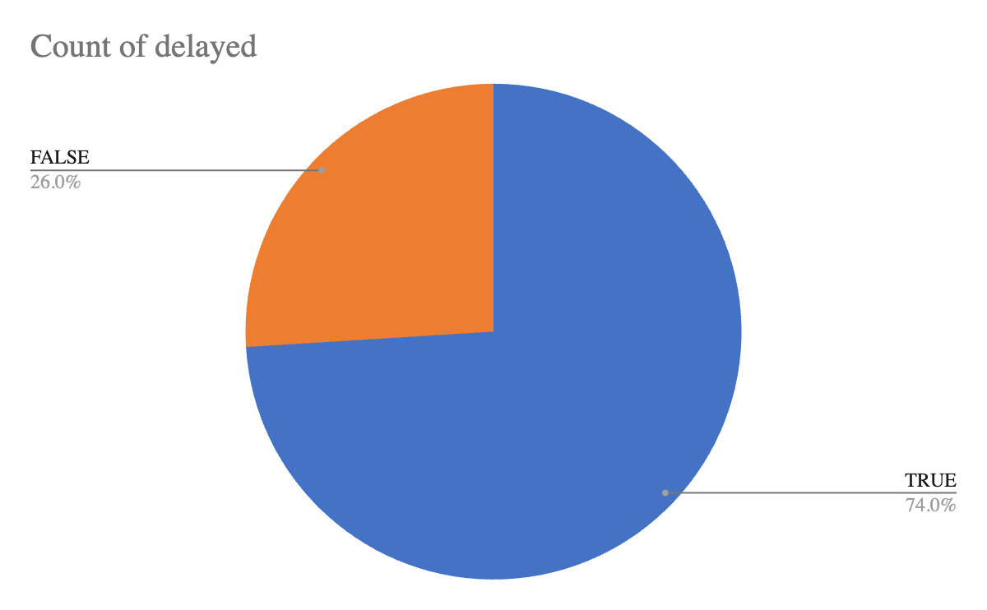

**Customer Feedback Data:**The analysis of "Customer Feedback" provides valuable insights into the satisfaction levels of customers regarding various aspects of the business. The overall satisfaction rate is determined to be 3.37 out of 5, indicating a moderate level of satisfaction among customers.

Upon further examination of the satisfaction ratings, it is observed that customers express the highest level of satisfaction with the quality of the orders, with an average rating of 4.25 out of 5. This indicates that the organisation excels in delivering products that meet or exceed customer expectations in terms of quality.

On the other hand, customers express the lowest level of satisfaction with the delivery time, with an average rating of 2 out of 5. This finding aligns with the problem statement, which highlighted the issue of delayed orders. The lower satisfaction rating for delivery time suggests that improvements are needed in the timely delivery of orders to meet customer expectations.

The distribution of satisfaction ratings across different aspects of the business provides valuable insights into areas of strength and areas that require improvement. By focusing on addressing the issues related to delivery time, the organisation can work towards improving customer satisfaction and enhancing the overall customer experience.

Graphical representations, such as bar charts or pie charts, can be used to visually depict the distribution of satisfaction ratings for each aspect. This visual representation can help identify areas where customer satisfaction is high and areas that need attention and improvement.

By analysing and understanding customer feedback, the organisation can make informed decisions and implement targeted strategies to enhance customer satisfaction, improve delivery times, and ultimately strengthen customer loyalty and retention.

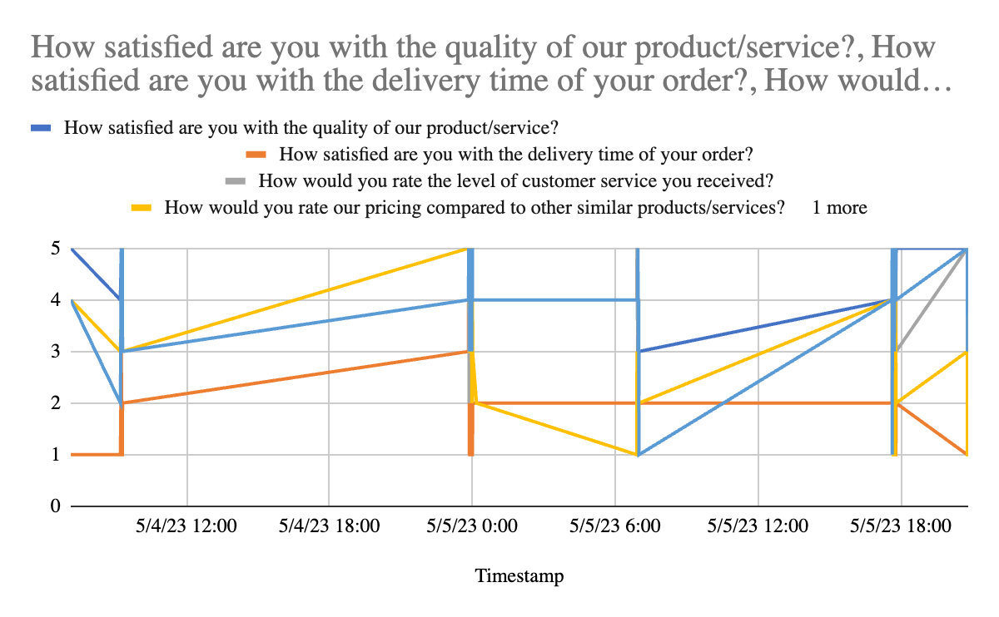

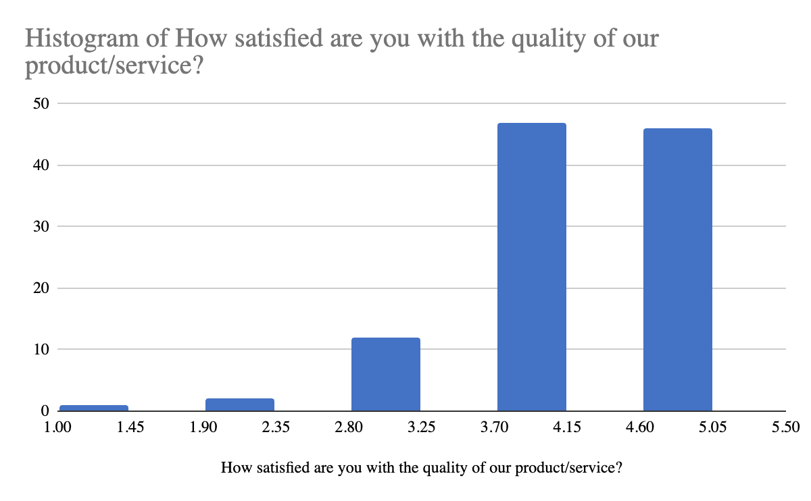

**Employee Feedback Data:**The analysis of "Employee Feedback" reveals that the overall satisfaction rate among employees is determined to be 2.94 out of 5. This indicates a moderate level of satisfaction among employees, suggesting that while they are not extremely satisfied, they are also not heavily dissatisfied with their work.

Upon further examination of the employee feedback, it is identified that there are areas that require improvement, particularly in terms of workload balance and satisfaction with assigned work. The rating for workload balance is 2.76, indicating that employees feel the need for a more balanced distribution of tasks and responsibilities. Similarly, the satisfaction rating for assigned work is 2.84, indicating that employees are not completely satisfied with the nature and quality of the tasks they are assigned.

To address these areas of improvement, the organisation should focus on optimising workload distribution, ensuring that tasks are assigned fairly and evenly among employees. This can help alleviate the burden on certain individuals while ensuring that everyone is actively engaged in meaningful work. Additionally, efforts should be made to enhance employee satisfaction with assigned work, which can be achieved by providing clear expectations, opportunities for skill development, and recognition for achievements.

By improving workload balance and addressing employee satisfaction with assigned work, the organisation can foster a more positive and motivating work environment. This, in turn, can lead to increased employee engagement, productivity, and overall job satisfaction. Regular feedback sessions, open communication channels, and employee recognition programs can be implemented to continuously monitor and improve these aspects.

Taking these steps to address the identified areas of improvement can contribute to enhancing employee satisfaction, fostering a positive work culture, and ultimately improving overall organisational performance.

Saleem has the lowest value for “How would you rate the support provided by management in terms of workload distribution and resource allocation?” (1) and values lower than most for “How would you rate your workload balance at present?” (1) and “Do you feel that you are able to complete your assigned tasks within the given time frame?” (1).

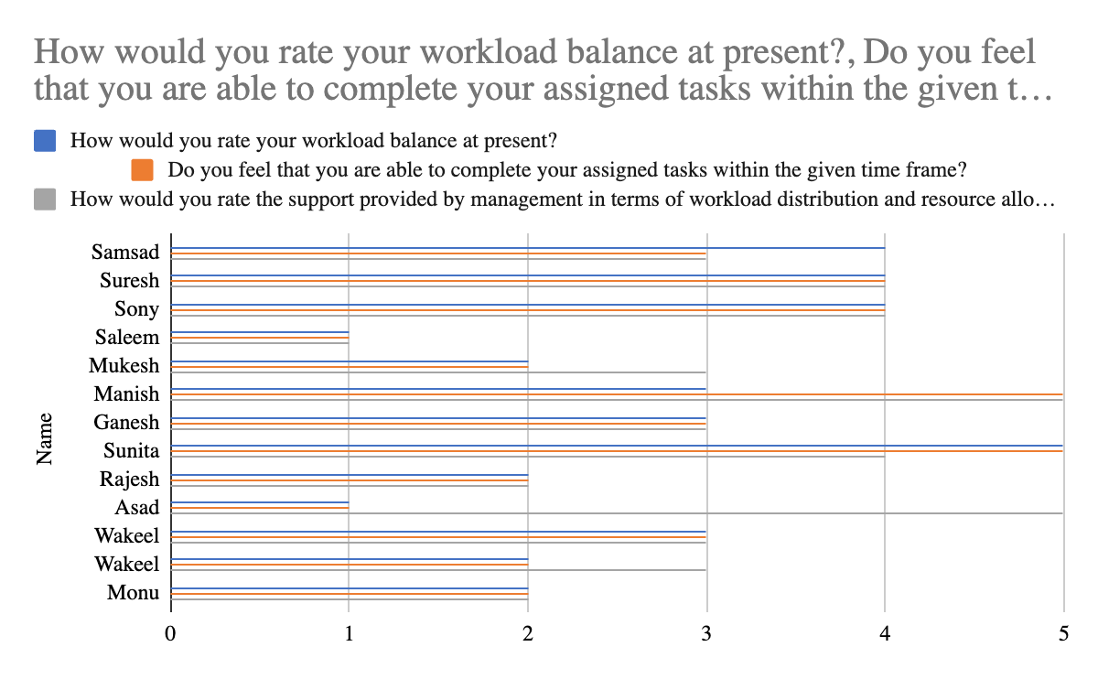

**Way Forward:**

Solution Development and Implementation:

* Develop practical and effective solutions considering workload balance, communication, management support, recognition, and rewards.
* Create an implementation plan with clear steps, resources, and timeline.
* Communicate the solutions to stakeholders and gain their support and commitment.

Monitoring and Evaluation:

* Implement the solutions and closely monitor their effectiveness.
* Collect feedback from customers, employees, and stakeholders.
* Regularly evaluate project progress against objectives and milestones.

Reporting and Documentation:

* Prepare a comprehensive final report summarising project findings, analysis results, and implemented solutions.
* Document the project process, including data collection, analysis techniques, and implementation strategies.

**Expected Timeline for Final Report:**

* Data Collection and Conversion: Until 13 May
  + Collect and convert required data into Excel format
* Data Analysis: 13 May- 16 May 2023
  + Perform analysis on sales volume, revenue, inventory management, and profit using the collected data.
* Report Writing: 15 May- 17 May 2023
  + Compile the findings from the data analysis into a comprehensive report.
* Final Report Completion: Targeted for 19th may 2023
* Complete the final report, ensuring it covers all the necessary aspects and findings.
  + Proofread and review the report for accuracy and clarity.